**THE ESP8266 AND THE ESP32 MICROCONTROLLERS**

Both the ESP32 and ESP8266 microcontrollers were developed by the **Espressif Systems** - **China** to be used in IoT applications.

***The ESP8266***

The ESP8266 was released by their manufacturers in 2014. The board gained popularity in late 2014 to 2015 when inexpensive boards became available. It was mainly meant to introduce the concept of addition of WiFi to a microcontroller but at the same time limiting the price incurred for such. It therefore offered a cheap WiFi System on Chip (Soc) for IoT OEMs with its own CPU that needed no host microcontroller to run user code. After its release, it gained popularity due to its low cost, integrated WiFi, reasonable processing power and simplicity.

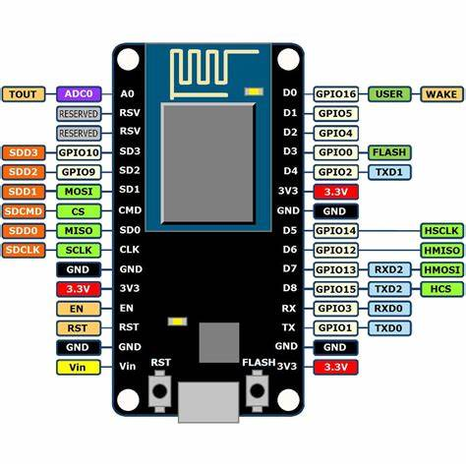

The core chip is named **ESP8266EX**. It has the following capabilities:

1. ***Processor and Core***

It has a 32bit Tensilica L106 microcontroller with an 80MHz clock speed that can be overclocked to 160MHz. It can achieve up to 100 DMIPS. It has a single core and an instruction cache to compensate for the speeds of the flash. It also supports RTOS via a software development kit.

1. ***Memory***

It has a total memory of 192KB SRAM with only 160 KB available to the user. It has no internal flash memory and often requires a Serial Peripheral Interface flash chip. In the event the module comes with flash, it has a chip of 1-4MB of flash memory.

1. ***Wireless Connectivity***

It has WiFi capabilities (IEEE 802.11) with 2.4 GHz band. It supports WPA/WPA2 security.

1. ***I/O and Peripherals***

It has up to 17 GPIO pins depending on the variant of the chip. The GPIOs can serve multiple functions.

* It supports up to 8 PWM channels.
* It has one ADC channel.
* 2 UART interfaces.
* 2 SPI interfaces with one being a high speed master/slave.
* It can support I2C and rarely 12S.
* Has multiple hardware and software timers with a basic real time clock.

1. ***Power Consumption and Sleep Modes***

It has an operating voltage of between 3-3.6V taking up currents of between 10 µA to 170mA depending on the power mode it is operating on. These include but is not limited to:

* Active Mode - 70 - 170 mA during WiFi transmission
* Modem Sleep - 15-20mA
* Light Sleep - 0.4mA
* Deep Sleep - 10 µA

It can be brought back online through use of timing functions or external GPIO options that are limited.

1. ***Security Features***

It has multiple security layers like the TLS/SSL. It also has WPA/WPA2 encryption but it is vulnerable to software based attacks if not better secured by the user.

1. ***Development and Programming***

It can support multiple programming languages like C, C++, MicroPython etc. It can also be used in development environments like the Arduino IDE which happens to be the most popular. It can also support MQTT, HTTP and Over the Air (OTA) updates.

The ESP8266 has multiple modules:

1. ESP-01 - is very small and has only 2 GPIOs.
2. ESP-12E/F - is the most popular. Has 11-17 GPIOs.
3. NodeMCU - has voltage regulation and ESP-12
4. Wemos D1 Mini - is a compact board with USB and full GPIO access.

*Advantages*

1. It is cheap.
2. It is easy to use and configure.
3. It is compact.
4. Has WiFi capabilities.
5. Has a low power usage.

*Disadvantages*

1. Has less GPIO pins
2. Has no bluetooth capability
3. Has only one ADC channel.
4. Single core; it therefore is less powerful and less ideal for multitasking.
5. Has a limited memory space.
6. Has no hardware crypto/ security support.

***The ESP32***

This microcontroller was developed due to the increasing need for industrial and commercial IoT as compared to the small scale use of the ESP8266. It was developed from around 2015 to address the shortcomings of the mother microcontroller and act as its powerful successor. The first dev kit was released into the market towards the end of 2016. The chip gained rapid popularity in professional and hobbyist markets. This chip could:

* Handle more complex applications, e.g. audio streaming and real time control.
* Add secure communication for production IoT devices.
* Support Bluetooth that cou;d be used for local wireless communication
* Improve multitasking and peripheral support.

This among many other functions enabled edge computing and application of the microcontroller to security sensitive applications.

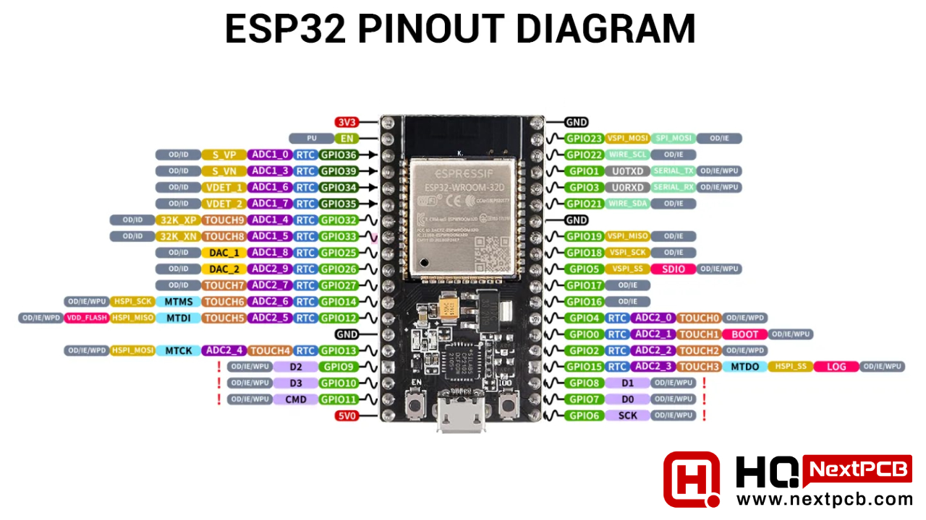

The mainline chip is named ESP32-D0WDQ6 or ESP32-WROOM-32 module. It is an SoC with WiFi and bluetooth.

1. ***Processor and Architecture***

It is a 32 bit Tensilica Xtensa LX6 microcontroller with a dual core. It has a clock speed of up to 240MHz. It has the ability to allow the different cores to run at independent speeds or even be powered down. It has an Ultra Low Power (ULP) 8 bit Coprocessor to allow sensor monitoring during deep sleep. It can execute up to 600 DMIPS for both cores.

1. ***Memory***

It has an internal SRAM of 520 KB, shared between data RA, instruction RAM and Cache. It supports external SPI flash memory up to 16 MB with most modules being availed with 4MB flash. Some modules like the ESP32-WROVER come with a PSRAM that can be quite useful for graphical applications that take up alot of storage.

1. ***Wireless Connectivity***

It has WiFi capabilities (IEEE 802.11) with 2.4 GHz band. It supports WPA/WPA2/Enterprise encryption. It also supports classic Bluetooth and Bluetooth Low Energy (BLE 4.2/ 5.0). The BLE supports multiple advertising, scanning and GATT services. Both the WiFi and BLE can be used simultaneously. The bluetooth is mostly applicable for remote controlling purposes.

1. ***Peripherals and I/O***

* *GPIOs-* it has up to 36 GPIO pins that can be configured as input, output, ADC, DAC, touch or PWM.
* *ADC-*  is of 12 bit resolution available on 18 channels/pins. There are 2 ADC units (physical ADC core in the chip), ADC1 and ADC2. ADC2 shares internal resources with the WiFi radio. Each unit can read from multiple GPIOs in general. However, the unit can only read from one channel at a time through use of multiplexing. ADC1 handles 8 channels ( GPIOs 32-39) while ADC2 handles 10 channels ( GPIOs 0, 2, 4, 12-15, 25-27).
* *DAC-* it has 2 8 bit channels
* *Touch Sensors-* it has 10 capacitive touch sensors that can be used for functions such as wakeup, UI or low power touch activation. They use capacitive touch technology.
* *12C-* has 2 I2C interfaces that can be used as either master or slave.
* *UART*- has 3 hardware supported UARTs.
* *12S*- is used as an audio interface for microphones and DACs.
* *PWM-* it has independent PWM channels available on all GPIOs.
* *CAN Bus-* it is supported on some modules. It is designed for robust and flexible performance in harsh environments and is useful for industrial applications.
* *Ethernet MAC-* has been integrated but requires an external PHY chip to enable its use. This physical layer chip will enable physical layer functions and is suitable for very short distance transmission.
* *Hall Effect Sensor-*  is used to measure magnetic fields without need to connect external modules.

1. ***Power Management and Sleep Modes***

The module can safely and efficiently operate within a voltage range of 3-3.6V. It takes up a current of between 5 µA and 240mA depending on the power mode it is operating in at a given moment. These include:

* Active- 160-240mA when using bluetooth and WiFi.
* Modem Sleep - 3-20mA.
* Light Sleep - 0.8 - 1.0mA
* Deep Sleep - 10 µA
* Hibernation - < 5 µA

It can be brought back online through use of timing functions, external GPIO options, touch pad or the coprocessor.

1. ***Security Features***

Its security features are upped from the esp8266 microcontroller. It has hardware acceleration for encryption. It also has secure boot that prevents unauthorized firmware from running. Flash encryption protects contents of external flash.

1. ***Development Environment***

It can support multiple programming languages like C, C++, MicroPython, Lua, JavaScript etc. It can also be used in development environments like the ESP-IDF and Arduino IDE which happen to be the most popular. It can also support MQTT, HTTP and Over the Air (OTA) updates.

The ESP8266 has multiple modules:

1. ESP32-WROOM-32 - is the most common module with 4MB flash.
2. ESP32-WROVER - it includes PSRAM (4-8 MB) and 4 MB flash.
3. ESP32-PICO-D4 - has fewer GPIOs with a compact design.
4. ESP32-S2/S3/C3 - is a new variant with unique features and architecture.

*Advantages*

1. Has a dual core processor hence can handle multitasking better.
2. Has more GPIOs with support for ADC, DAC, capacitive touch, PWM, SPI, I2C, I2S UART etc.
3. Has bluetooth and WiFi support.
4. Has a larger memory capacity.
5. Has good hardware security features.
6. Has multiple low power modes.

*Disadvantages*

1. Has a high power consumption.
2. Can be complex in use for beginners.
3. Is slightly expensive.
4. Is wider in physical sense and hence can be a problem in compact designs.
5. It has no built in display driver unless connected via a Serial Peripheral Interface.
6. The WiFi and Bluetooth share a common radio. When loaded, the microcontroller may end up experiencing a performance drop due to the internal conflict.
7. There is limited ADC accuracy and linearity especially when the WiFi is active. This is because the ADC2 unit and WiFi share internal resources. This may lead to a slack in performance and drop in accuracy when the two are used simultaneously.
8. It requires good power supply decoupling as it has sensitive analog and radio frequency performance.

**APPLICATIONS OF THE MICROCONTROLLERS TO VARIOUS SATELLITE SUBSYSTEMS.**

1. *Controller (On board computer - OBC)*

The ESP32 is preferred due to its higher processing ability, multitasking and built-in peripheral support. It is however not radiation hardened and may need reset logic for reliability.

1. *Communication System*

The ESP32 would be preferred due to its Bluetooth and WiFi capabilities. This will however only be useful for short range telemetry and data dump for ground testing. It has the capability of handling the bandwidth required by the hobby satellite but it would be better if it would be complemented by other modules especially for RF applications.

1. *Electrical Power System (EPS)*

ESP32 would be better used due to its multiple GPIOs, ADC capabilities and low power modes. It can handle power monitoring with ADCs, control relays and switches. Deep sleep can be employed for power saving. It however needs efficient power management.

1. *Attitude Determination and Control System (ADCS)*

ESP32 can be used with external coprocessors for a more precise orientation control. It can be used with IMUs (Inertial Measurement Units), magnetometers, sun sensors and others. Its dual core allows for parallel sensor reading and processing.

1. *Payload*

The ESP32 has a camera interface that can handle simple image capture and sensor interfacing. It can not, however, handle large images due to its limited image processing capacity and memory.

1. *Structure and Integration*

This mostly involves mechanical design and is not necessarily controlled by a microcontroller.

1. *Telemetry command and Data Handling*

The ESP32 is better as it can handle larger amounts of data better due to its dual core and faster speeds. It has more storage capacity and multiple channels for interfacing with subsystems. It does have non volatile storage that can be used for storing telemetry logs without need of power supply. In addition, it has RTOS support that allows scheduling of tasks and reliable data management.

**CONCLUSION.**

All factors considered, the ESP32 is undoubtedly more useful and wide in its scope of application. This can even simply be based on the various improvements made by the manufacturers to address the shortcomings of the ESP8266 microcontroller. This has been demonstrated by the massive capabilities of the ESP32 microcontroller.

Taking into account all the advantages and disadvantages of the presented microcontrollers as applied in the various subsystems, the ESP32 would be suited to serve the ***Telemetry Command and Data Handling Subsystem*** as it can handle a large chunk of data from various peripherals, and so at a good speed. The only limitation it presents is the power it consumes while in use which is indeed a worthy trade off.